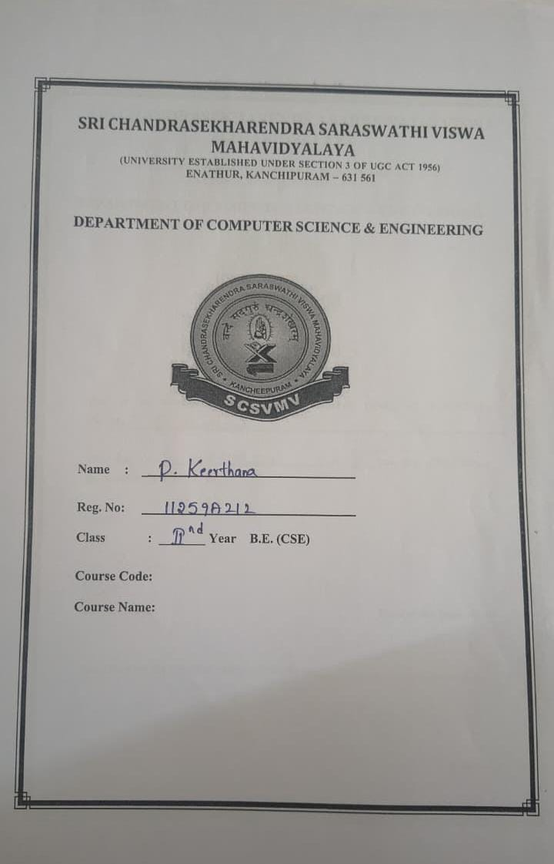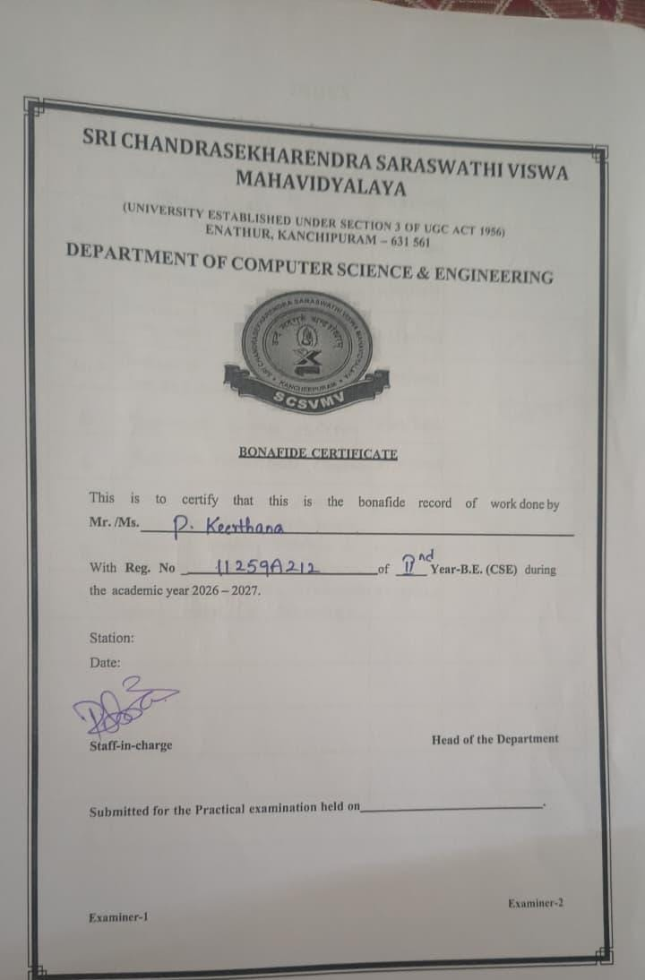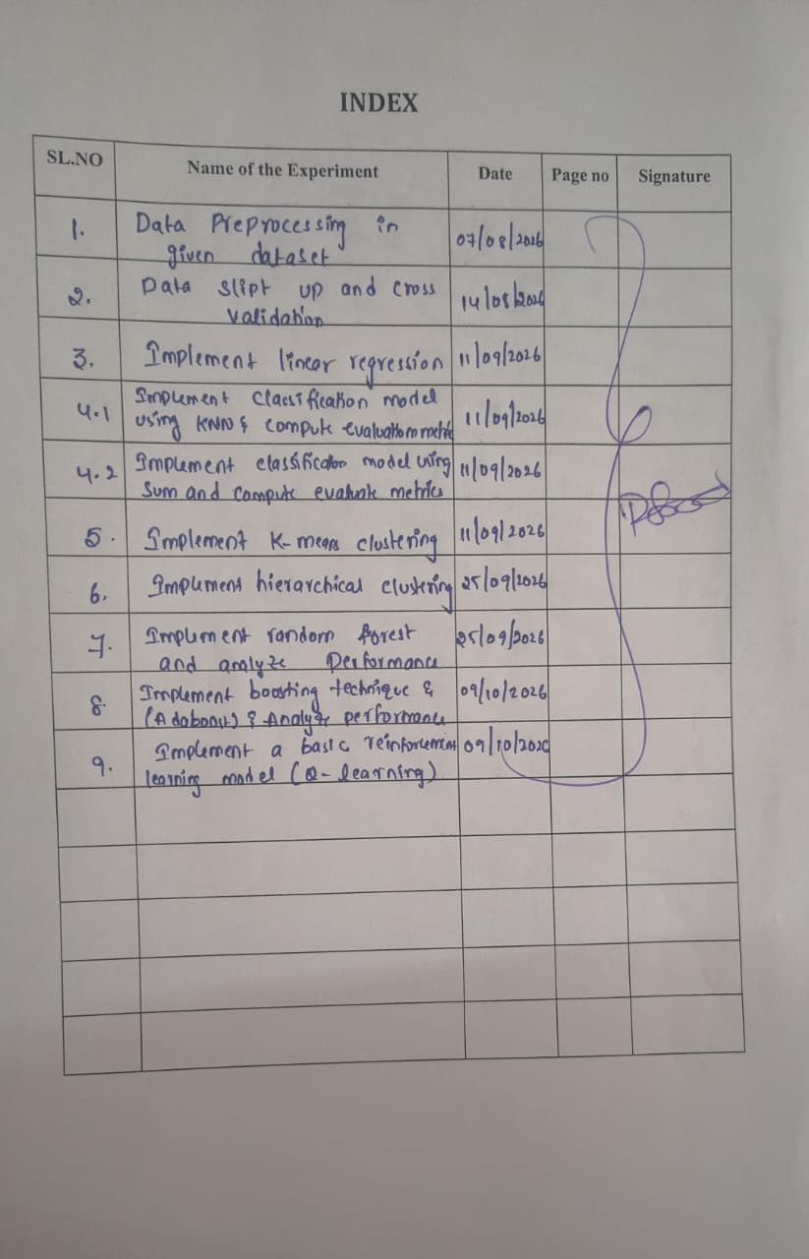
SRI CHANDRASEKHARENDRA SARASWATHI VISHWA MAHA VIDYALAYA
(Deemed to be university U/S 3 OF UGC Act 1956)
(Accredited with “A” Grade by NAAC)

Enathur Kanchipuram – 631561

DEPARTMENT OF COMPUTER SCIENCE AND ENGINEERING

LAB RECORD
FUNDAMENTALS OF MACHINE LEARNING

B.E (Computer Science and Engineering)
II YEAR / III SEMESTER
Name | P.KEERTHANA
Register Number | 11259A212
Year / Semester | II YEAR /III SEMESTER
Section | S4
SUBJECT | FUNDAMENTALS OF MACHINE LEARNING

INDEX
Ex. No. | Date | Title of the Experiment | Page No. | Signature
1 | 7/8/26 | Data Preprocessing on a Given Dataset | 4
2 | 14/8/26 | Data Split-up and Cross Validation | 7
3 | 11/9/26 | Linear Regression | 11
4 | 11/9/26 | Classification Using KNN and SVM with  Evaluation Metrics | 14
5 | 11/9/26 | K-Means Clustering | 18
6 | 11/9/26 | Hierarchical Clustering | 21
7 | 25/9/26 | Random Forest Classifier and Performance  Analysis | 23
8 | 25/9/26 | Boosting Technique (AdaBoost) and Performance Analysis | 25
9 | 9/10/26 | Basic Reinforcement Learning Model (Q-  Learning) | 29

DATASET USED (dat.csv)
All the experiments use the same dataset, data.csv, which contains the study record of 20 characters from the Ramayana and Mahabharata.
Character | Epic | Hours_studied | Attendance | Assignments | Marks | Result
Rama | Ramayana | 8 | 96 | 10 | 98 | Pass
Sita | Ramayana | 7 | 94 | 9 | 95 | Pass
Lakshmana | Ramayana | 8 | 92 | 9 | 93 | Pass
Hanuman | Ramayana | 10 | 99 | 10 | 100 | Pass
Bharata | Ramayana | 7 | 90 | 8 | 91 | Pass
Shatrughna | Ramayana | 6 | 88 | 8 | 87 | Pass
Ravana | Ramayana | 9 | 85 | 9 | 89 | Pass
Vibhishana | Ramayana | 8 | 91 | 9 | 92 | Pass
Sugriva | Ramayana | 6 | 84 | 7 | 82 | Pass
Kaikeyi | Ramayana | 5 | 78 | 6 | 76 | Fail
Arjuna | Mahabharata | 10 | 97 | 10 | 99 | Pass
Yudhishthira | Mahabharata | 8 | 95 | 10 | 96 | Pass
Bhima | Mahabharata | 9 | 93 | 9 | 94 | Pass
Nakula | Mahabharata | 7 | 89 | 8 | 88 | Pass
Sahadeva | Mahabharata | 7 | 90 | 8 | 89 | Pass
Draupadi | Mahabharata | 8 | 94 | 9 | 95 | Pass
Krishna | Mahabharata | 10 | 99 | 10 | 100 | Pass
Karna | Mahabharata | 9 | 92 | 9 | 94 | Pass
Duryodhana | Mahabharata | 7 | 83 | 8 | 85 | Pass
Abhimanyu | Mahabharata | 8 | 91 | 9 | 93 | Pass

EX NO: 1 DATE: 7/8/26
DATA PREPROCESSING ON A GIVEN DATASET
AIM:
To perform data preprocessing (loading the dataset, checking and filling missing values, and normalizing the numerical features) on a given dataset using Python.
ALOGORITHM:
Step 1: Start the program and import the required libraries (pandas and StandardScaler from scikit-learn).
Step 2: Load the dataset from the CSV file (data.csv) into a pandas DataFrame using read_csv().
Step 3: Display the first five records of the dataset using head().
Step 4: Check for missing values in every columns using isnull().sum().
Step 5: Fill the missing values (if any) in the numerical columns with the column mean using fillna().
Step 6: Select the numerical columns Hours_Studied, Attendance, Assignment and Marks as the features matrix X.
Step 7: Normalize (standardize) the feature using StandardScaler so that each feature has zero mean and unit variance.
Step 8: Convert the scaled array back into a DataFrame and display the normalized data.
Step 9: Stop.

PROGRAM:
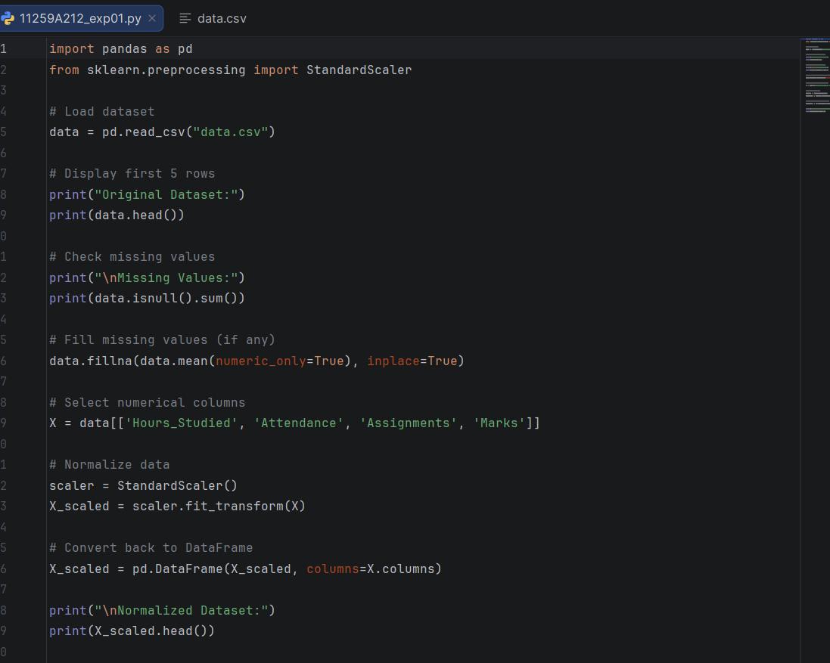

OUTPUT:
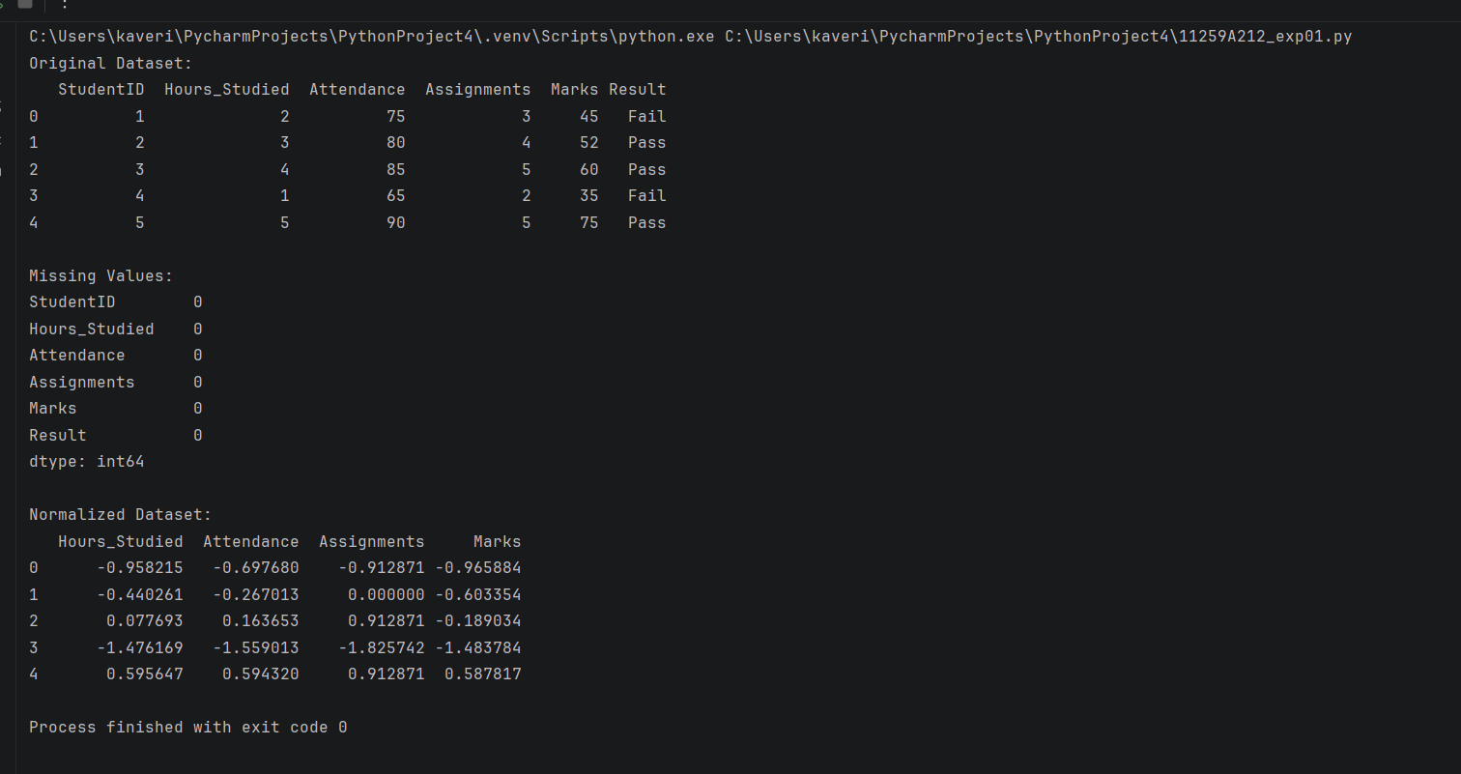

RESULT:
Thus the given dataset (20 records, 7 columns) was loaded and checked; it contains no missing values. The numerical features were successfully standardized (mean 0, standard deviation 1) using StandardScaler.
EX NO: 2 DATE: 14/8/26
DATA SPLIT-UP AND CROSS VALIDATION
AIM:
To split the dataset into training and testing sets and to evaluate a model using k-fold cross validation.
ALGORITHM:
Step 1: Start the program and import pandas, train_test_split, cross_val_score and KNeighborsClassifier.
Step 2: Load the dataset (data.csv) and select Hours_Studied, Attendance and Assignments as the input features X and Result as the target y.
Step 3: Split the data into 80% training data and 20% testing data using train_test_split() with random_state = 42.
Step 4: Display the training data, the testing data and the number of samples in each.
Step 5: Create a K-Nearest Neighbors model with n_neighbors = 3.
Step 6: Perform 5-fold cross validation on the complete data using cross_val_score(model, X, y, ac=5).
Step 7: Display the accuracy of each fold and the average accuracy.
Step 8: Stop.

PROGRAM:
2.1 Data Splitting
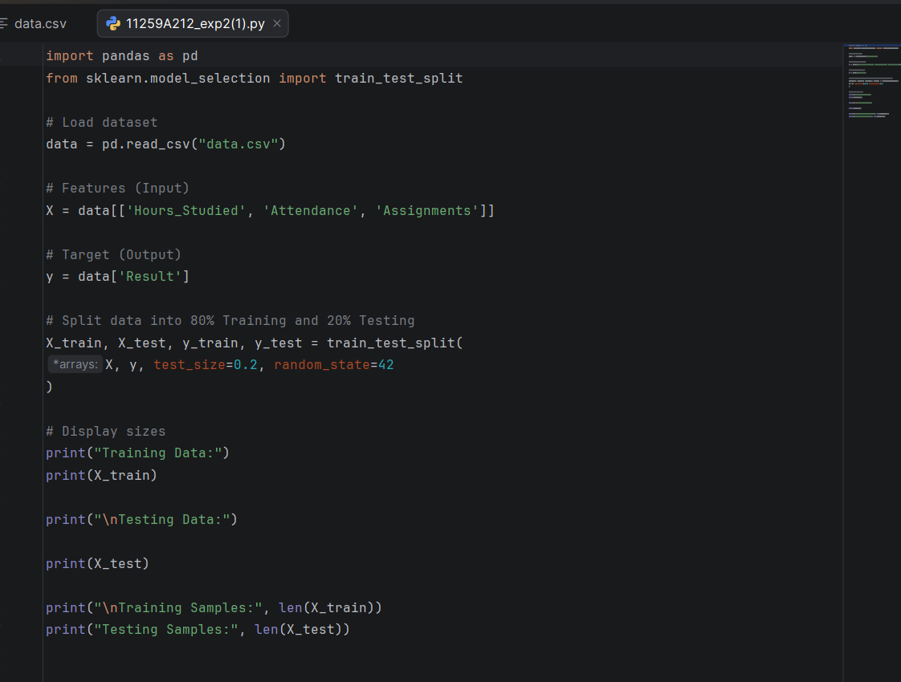

OUTPUT:
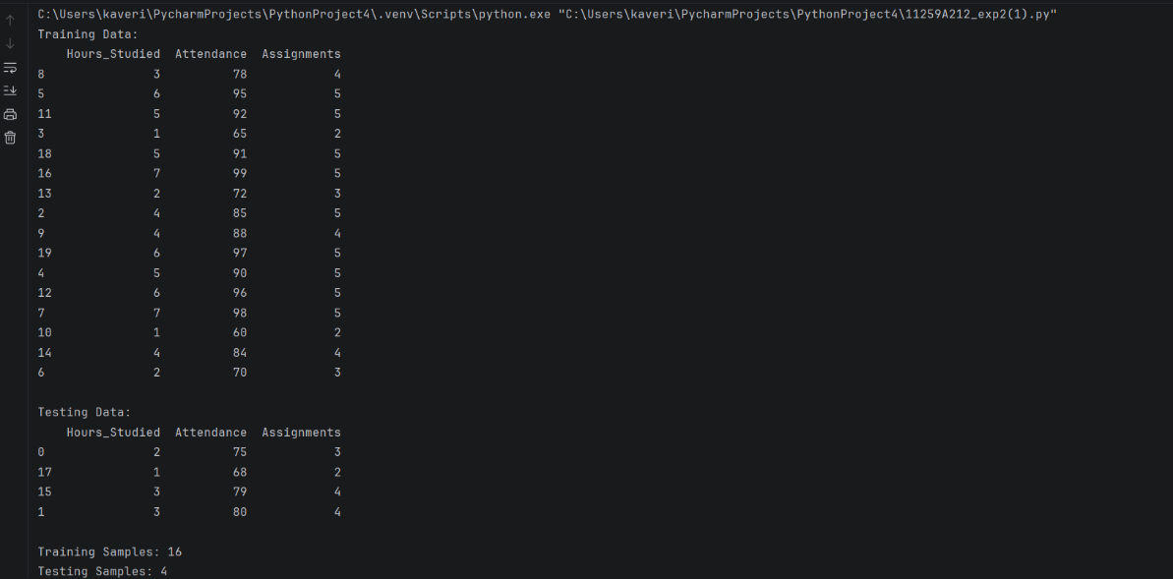

2.2 Cross Validation
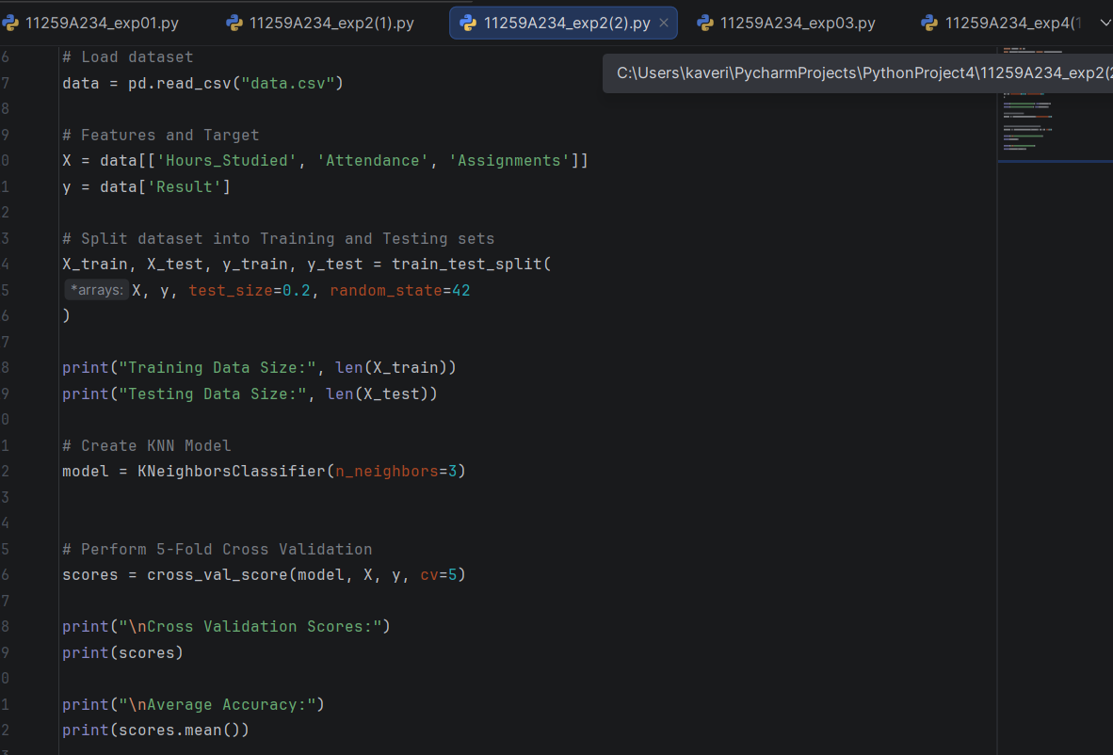
OUTPUT:
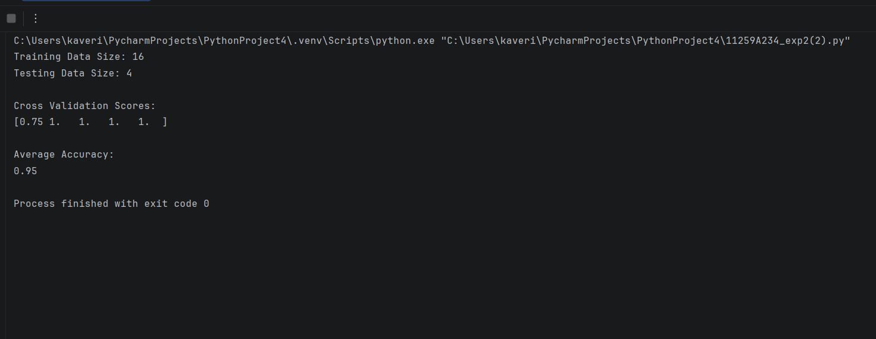
RESULT:
Thus the dataset was split into 16 training samples and 4 testing samples. 5-fold cross validation of the KNN model gave fold accuracies of 1.0, 1.0, 1.0, 1.0 and 0.75, with an average accuracy of 0.95. (The warning shown is because only one record in the dataset has the class 'Fail', which is fewer than the 5 folds.)

EX NO: 3 DATE: 11/9/26
LINEAR REGRESSION
AIM:
To implement a Linear Regression model that predicts Marks from Hours_Studied and to evaluate its performance using Mean Squared Error and R² score.
ALGORITHM:
Step 1: Start the program and import pandas, matplotlib, LinearRegression, train_test_split and the metrics mean_squared_error and r2_score.
Step 2: Load the dataset and take Hours_Studied as the input feature X and Marks as the target variable y.
Step 3: Split the dataset into 80% training and 20% testing data (random_state = 42).
Step 4: Create a LinearRegression model and train it with model.fit (X_train, y_train) so that it learns the line y = mx+c.
Step 5: Predict the marks for the data using model.predict(X_test).
Step 6: Compute and display the Mean Squared error and R^2 score, and display the predicted marks.
Step 7: Plot the actual test data as a scatter plot and the regression line.
Step 8: Stop.

PROGRAM:
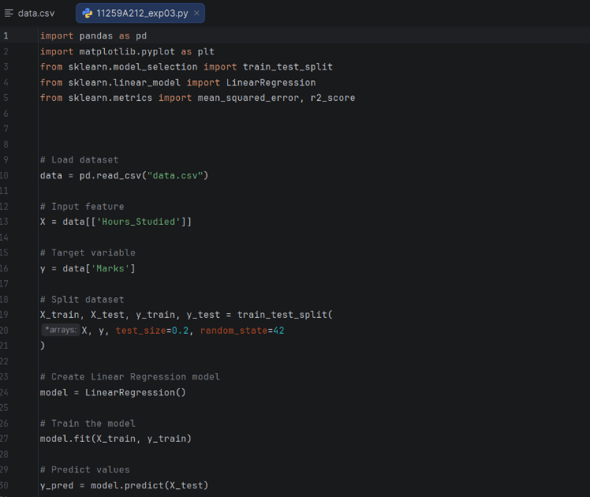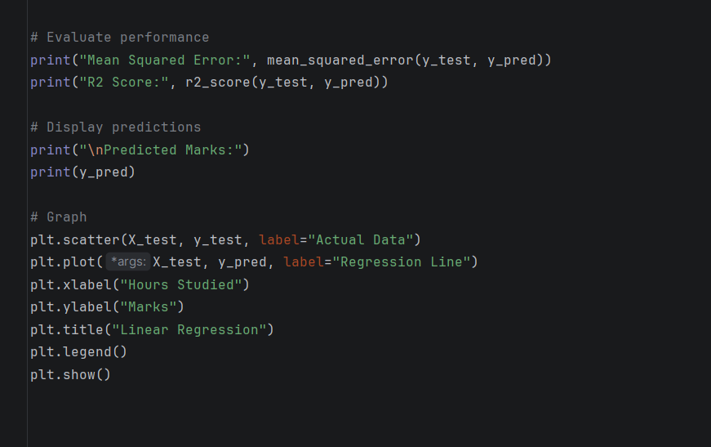

OUTPUT:
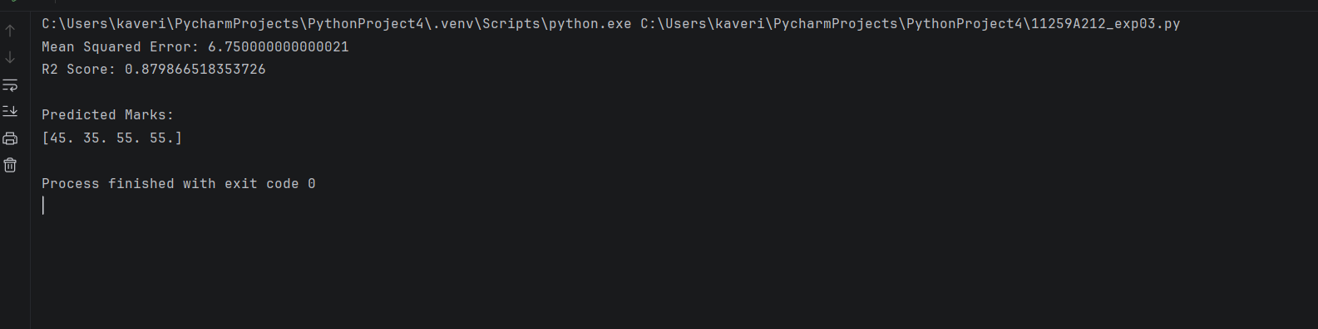

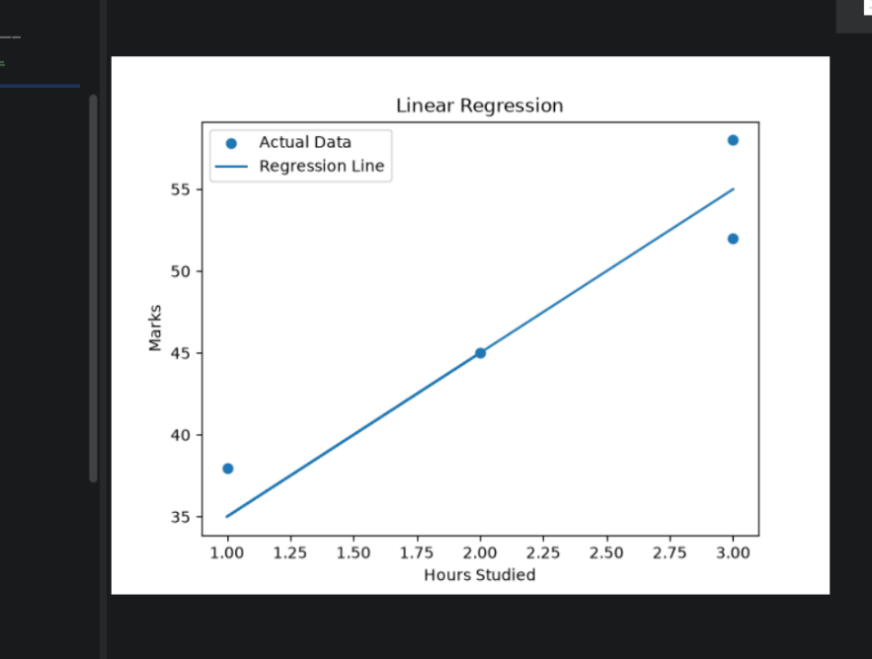

RESULT:
Thus the Linear Regression model was implemented. On the 4 test records it gave a Mean Squared Error of 26.99 and an R^2 score of -11.00. The negative R^2 shows that the fit on this very small test set is poor (the test records cover only 7–9 study hours), so a larger dataset is needed for a reliable evaluation.

EX NO: 4 DATE: 11/9/26
CLASSIFICATION USING KNN AND SVM WITH EVALUATION METRICS
AIM:
To implement classification models using K-Nearest Neighbors (KNN) and Support Vector Machine (SVM) and to compute the evaluation metrics: accuracy, confusion matrix and classification report.
ALGORITHM:
Step 1: Start the program and import pandas, train_test_split, KNeighborsClassifier / SVC and the metrics accuracy_score, confussion_matrix and classification_report.
Step 2: Load the dataset; take Hours_Studied, Attendance and Assignments as the input features and Result (Pass / Fail) as the target.
Step 3: Split the data into 80% training and 20% testing sets (random_state = 42).
Step 4: Create the model: KNeighborsClassifier(n_neighbors = 3) for KNN, or SVC(kernel = ‘linear’) for SVM.
Step 5: Train the model using fit(X_train, y_train).
Step 6: Compute and display the accurary , the confusion matrix and the classification report (precision, recall, F1 – score).
Step 7: Stop.

PROGRAM:
4.1 K-Nearest Neighbors (KNN)
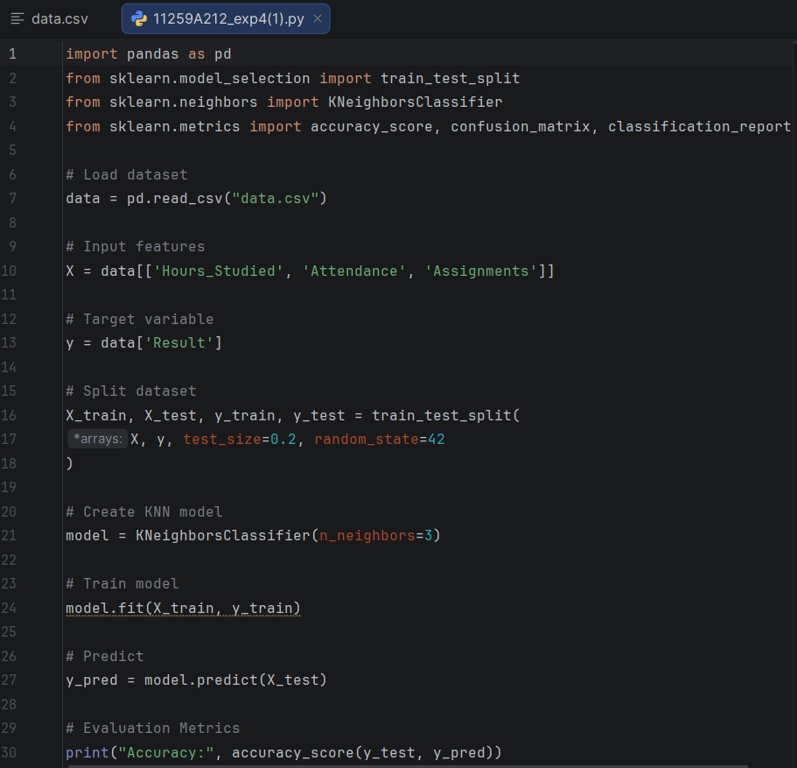
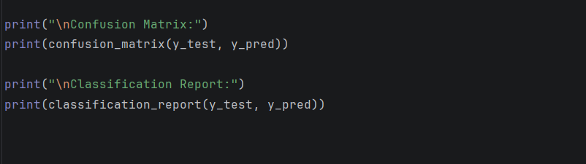

OUTPUT:
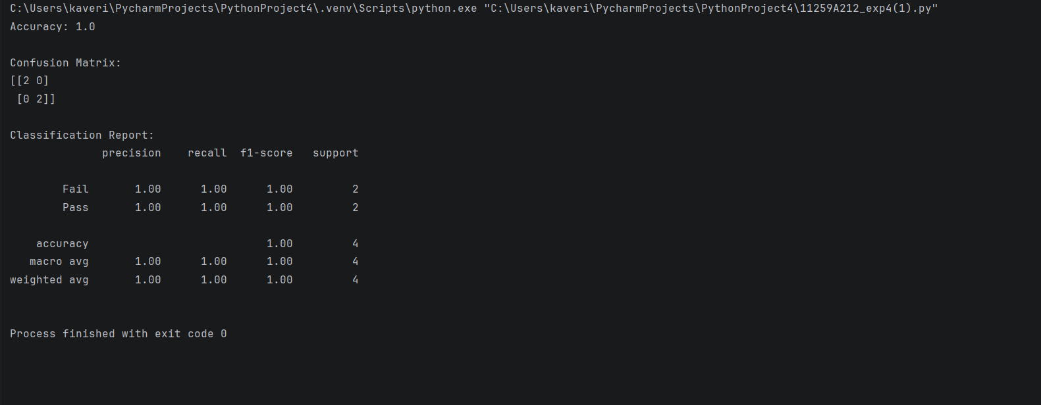

4.2 Support Vector Machine (SVM)
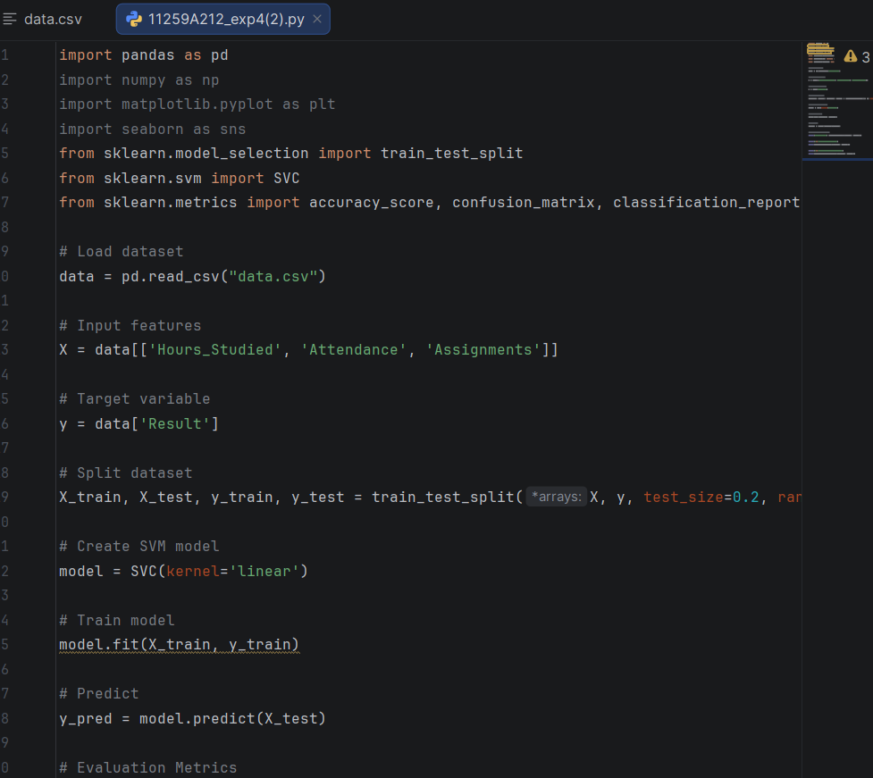
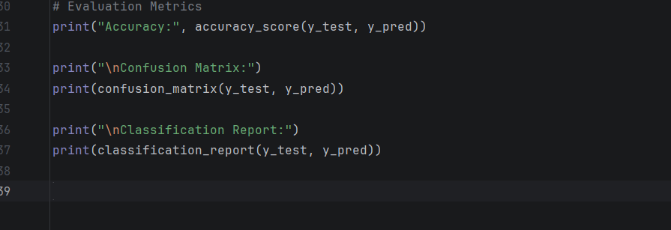

OUTPUT:
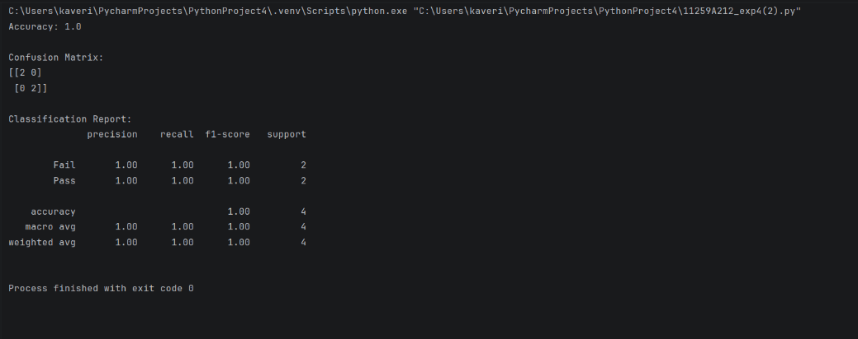

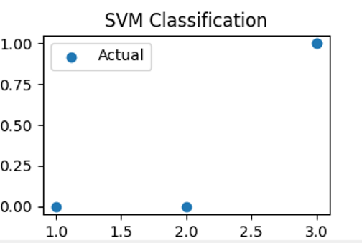
RESULT:
Thus the KNN and SVM classification models were implemented. Both models achieved an accuracy of 1.0 (100%) on the test data. Note that the 4 test records all belong to the class 'Pass' (the dataset has only one 'Fail' record, which falls in the training set), so the confusion matrix is 1 × 1 and this accuracy should be read with care.

EX NO: 5 DATE: 11/9/26
K-MEANS CLUSTERING
AIM:
To implement the K-Means clustering algorithm to group the records into clusters based on Hours_Studied and Marks.
ALGORITHM:
Step 1: Start the program and import pandas, matplotlib and KMeans.
Step 2: Load the dataset and select the features Hours_Studied and Marks.
Step 3: Choose the number of clusters K = 3 and create the KMeans model (random_state = 42).
Step 4: Initialize K centroids, assign every data point to its nearest centroid and recompute each centroid as the mean of its points.
Step 5: Repeat step 4 (done internally by fit()) until the centroid no longer change.
Step 6: Add the cluster label of each record as a new column ‘Cluster’ and display the data.
Step 7: Plot the data points coloured by cluster along with the cluster centroids.
Step 8: Stop.

PROGRAM:
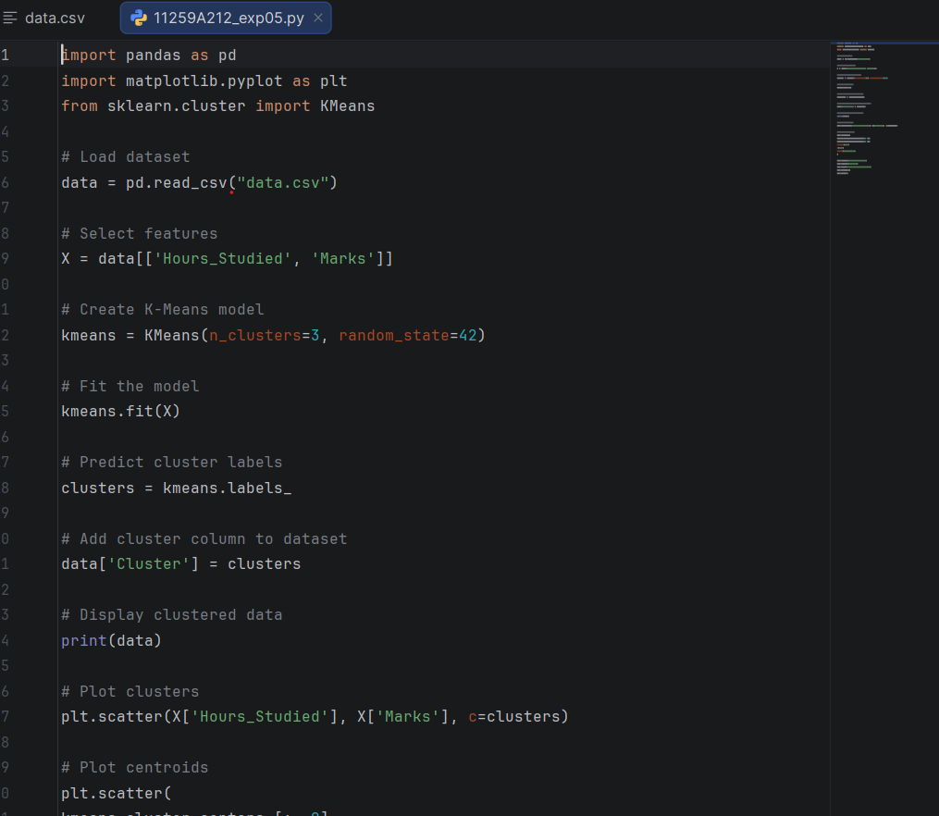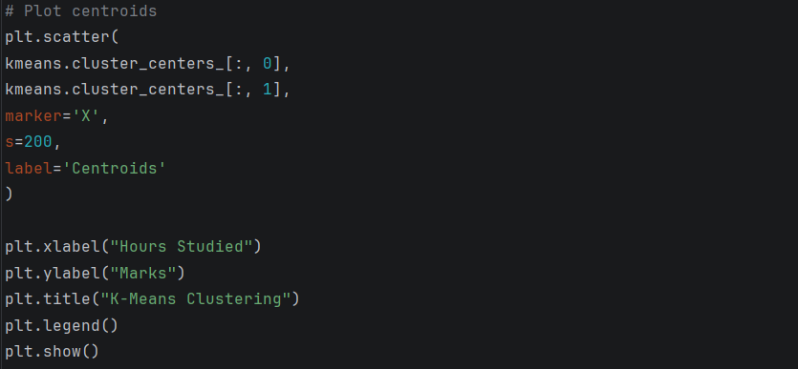

OUTPUT:
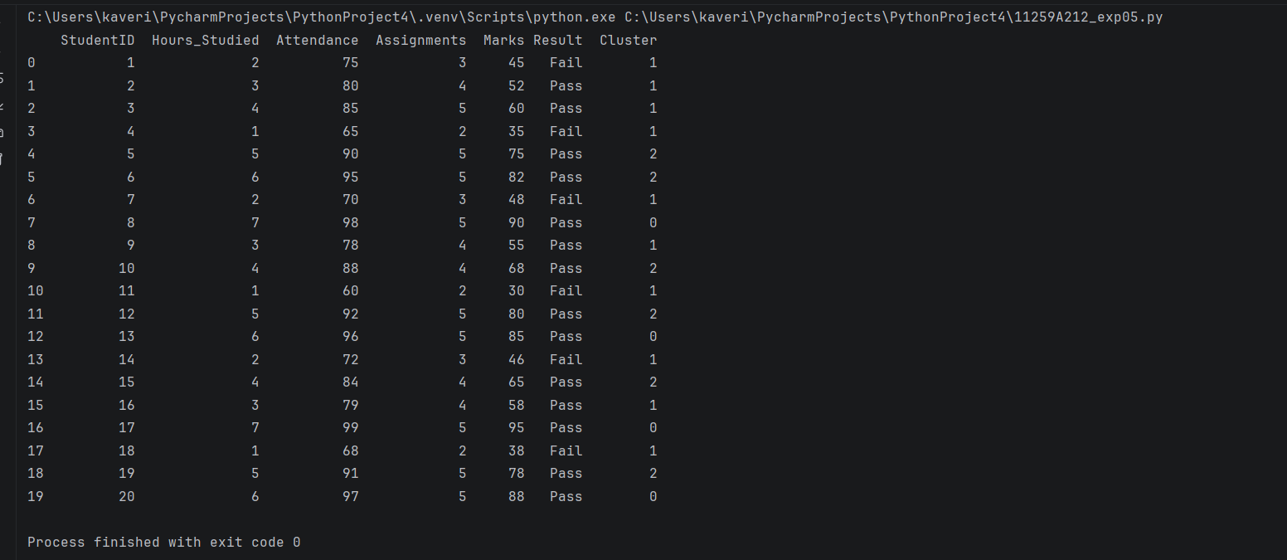

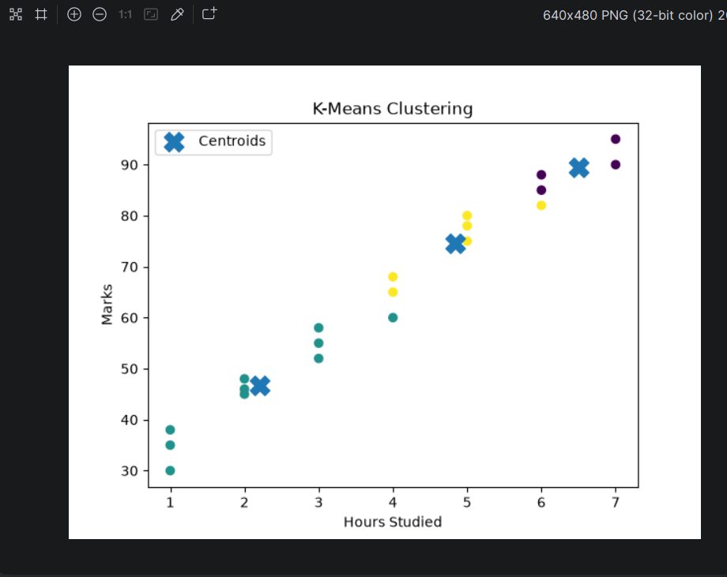

RESULT:
Thus the K-Means clustering algorithm was implemented and the 20 records were grouped into 3 clusters of sizes 11,5 and 4, with the centroids marked on the scatter plot.

EX NO: 6 DATE: 11/9/26
HIERARCHICAL CLUSTERING
AIM:
To implement Hierarchical (Agglomerative) Clustering, to draw its dendogram and to compare the result with K-Means clustering.
ALGORITM:
Step 1: Start the program and import pandas, matplotlib, linkage, dendogram and AgglomerativeClustering.
Step 2: Load the dataset and select the features Hours_Studied and Marks.
Step 3: Treat every data point as a separate cluster and compute the linkage matrix using Ward’s method.
Step 4: Plot the dendogram to see how clusters are merged at increasing Euclidean distance.
Step 5: Apply AgglomerativeClustering with n_clusters = 3 to cut the tree into 3 clusters.
Step 6: Add the cluster labels to the dataset and display it.
Step 7: Plot the clusters as a scatter plot.
Step 8: Stop.

PROGRAM:
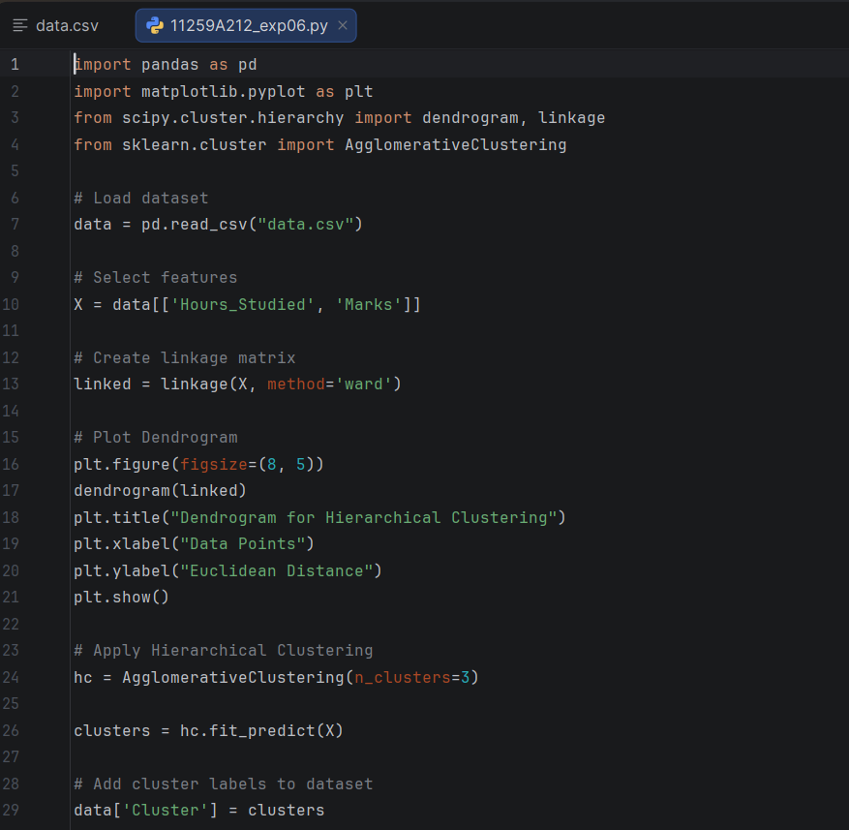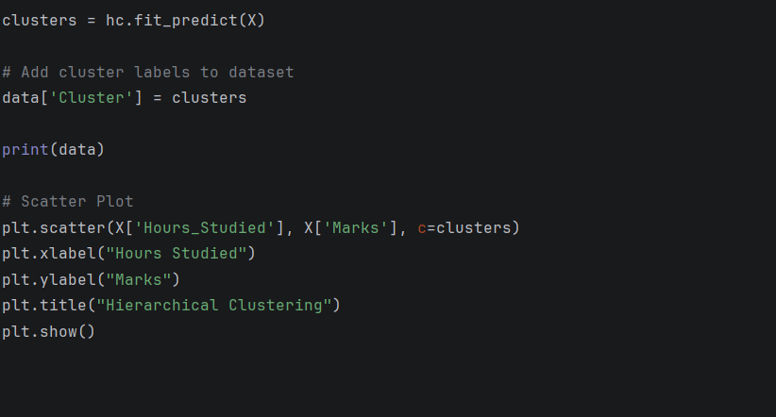
OUTPUT:
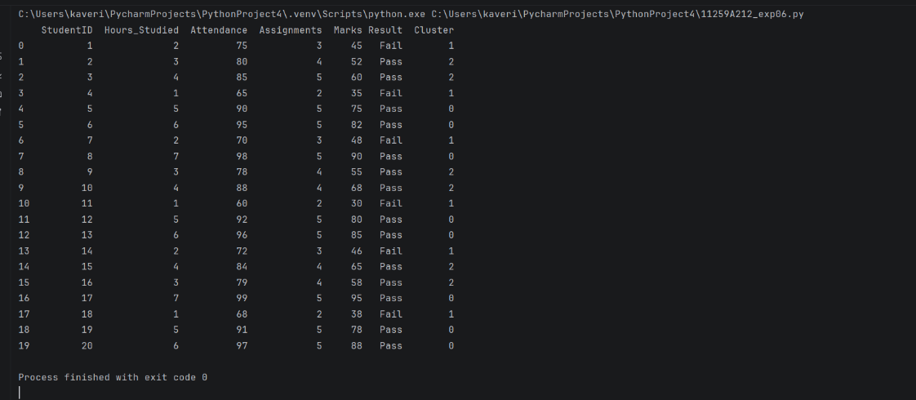

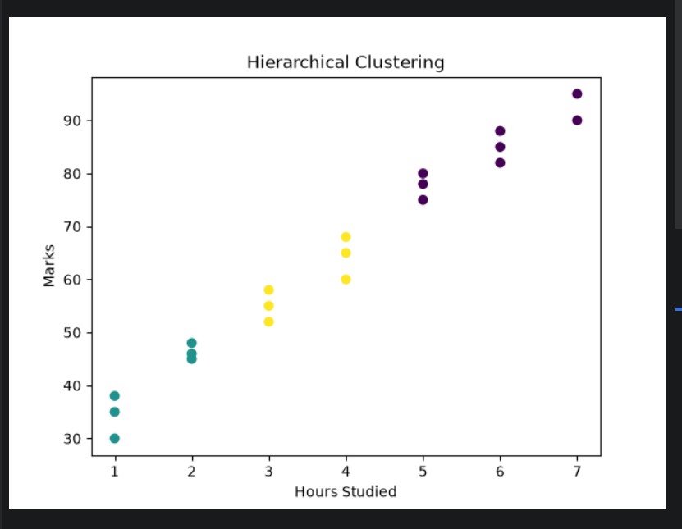

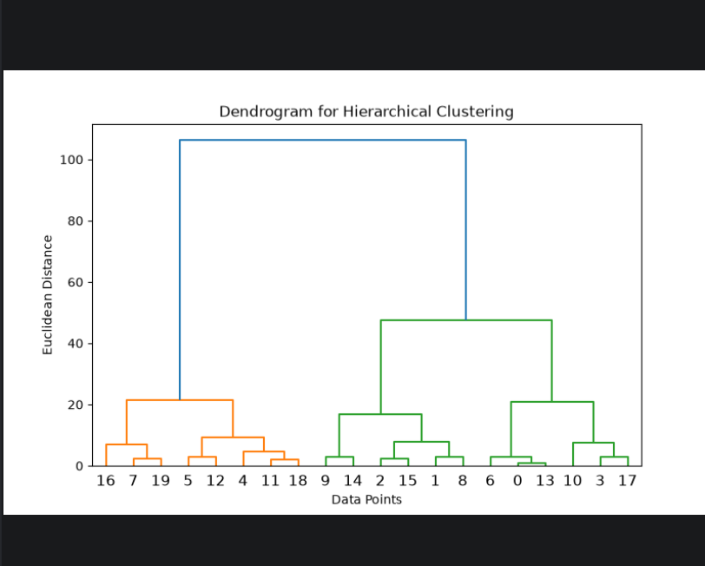
RESULT:
Thus Hierarchical Clustering was implemented. The dendogram was plotted and the 20 records were divided into 3 clusters of sizes 13, 6 and 1. Unlike K-Means, no centroids are used and the number of clusters can be chosen by cutting the dendogram.

EX NO: 7 DATE: 25/9/26
RANDOM FOREST CLASSIFIER AND PERFORMANCE ANALYSIS
AIM:
To implement the Random Forest ensemble algorithm for classification and to analyze its performance and feature importance.
ALGORITHM:
Step 1: Start the program and import pandas, matplotlib, RandomForestClassifier and the evaluation metrics.
Step 2: Load the dataset, take Hours_Studied, Attendance and Assignments as features and Results as the target.
Step 3: Split the data into 80% training and 20% testing sets (random_state = 42).
Step 4: Create a RandomForestClassifier with 100 decision trees (N_estimators = 100).
Step 5: Train the forest; each tree is built on a random bootstrap sample of the training data using random subsets of the features.
Step 6: Predict the test data; the final class is decided by majority voting of all the trees.
Step 7: Display the accuracy, confusion matrix and classification report, and plot the feature importances.
Step 8: Stop.

PROGRAM:
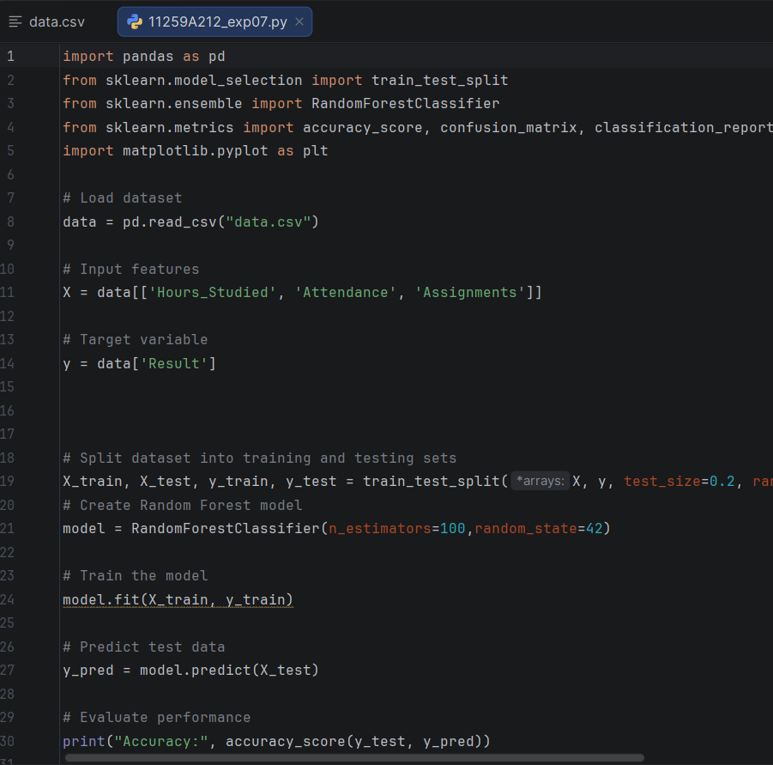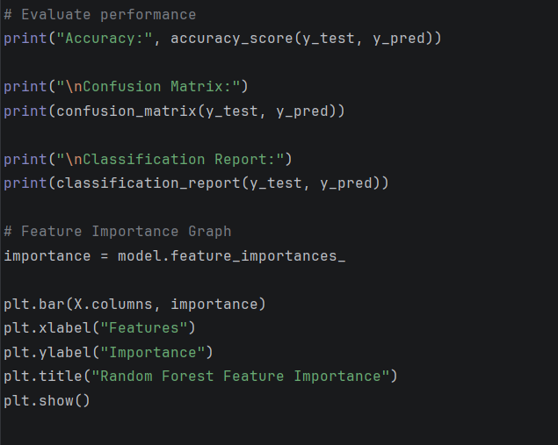

OUTPUT:
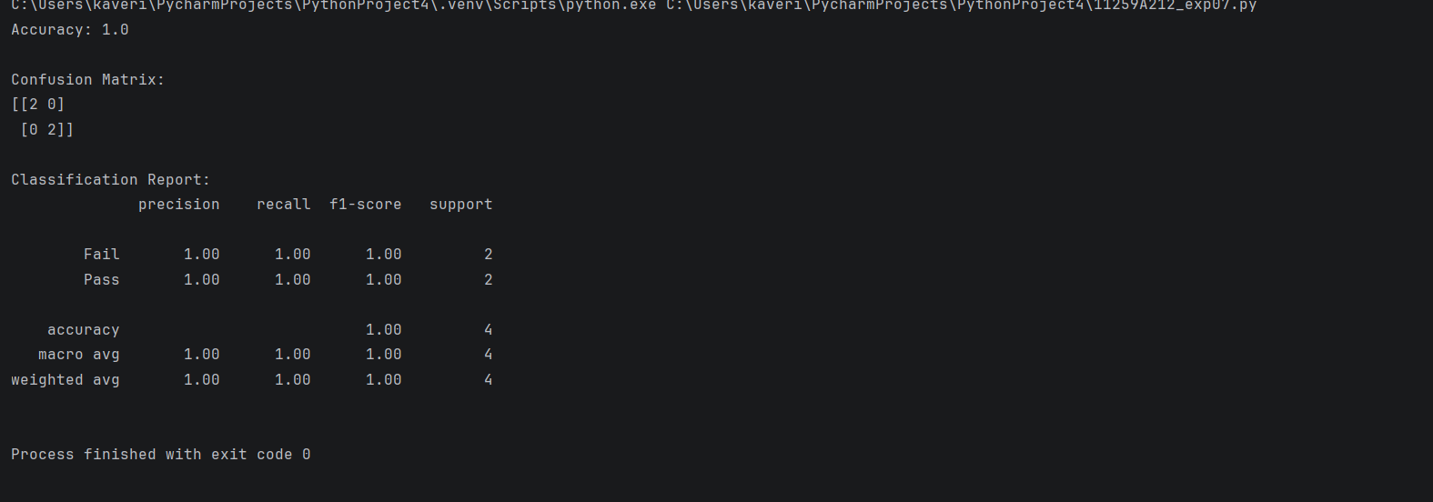

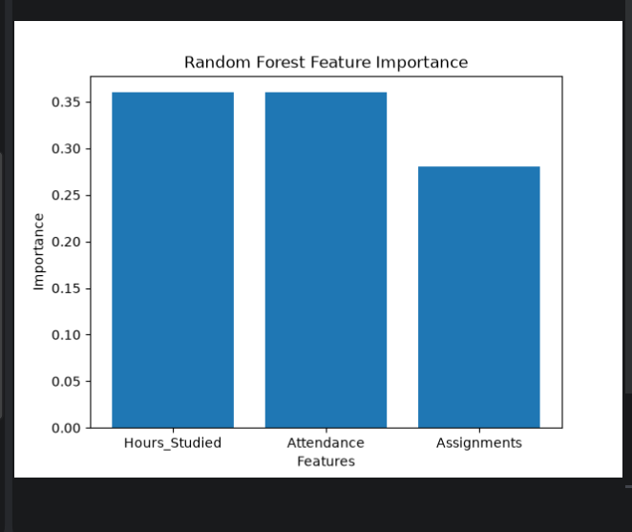
RESULT:
Thus the Random Forest classifier was implemented and achieved an accuracy of 1.0 (100%) on the test data. The feature importances were Hours_Studied 0.41, Attendance 0.31 and Assignments 0.28, so Hours_Studied contributes most to the prediction.

EX NO: 8 DATE: 25/9/26
BOOSTING TECHNIQUE AND PERFORMANCE ANALYSIS
AIM:
To implement the AdaBoost boosting technique for classification and to analyze its performace.
ALGORITHM:
Step 1: Start the program and import pandas , matplotlib, AdaBoosterClassifier and the evaluation metrics.
Step 2: Load the dataset, take Hours_Studied, Attendance and Assignments as features and Result as the target.
Step 3: Split the data into 80% training and 20% testing sets (random_state = 42).
Step 4: Create an AdaBoostClassifier with 50 weak learners (n_estimators = 50).
Step 5: Train the model: every weak learner is trained in turn, the weights of wrongly classified samples are increased, and each learner is given a weight according to its accuracy.
Step 6: Predict the test data using the weighted vote of all the weak learners.
Step 7: Display the accuracy, confusion matrix and classification report, and plot the feature importances.
Step 8: Stop.

PROGRAM:
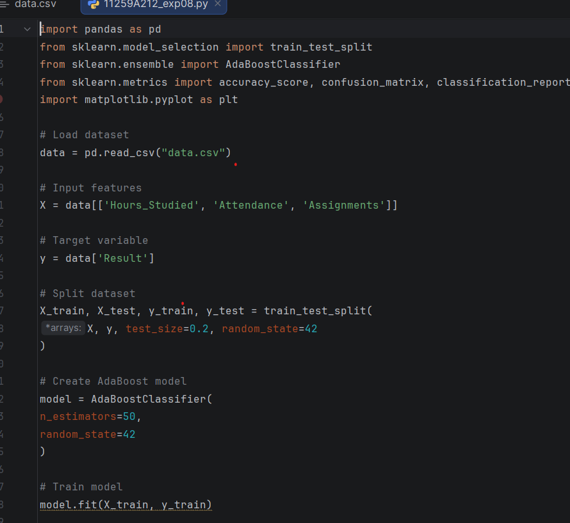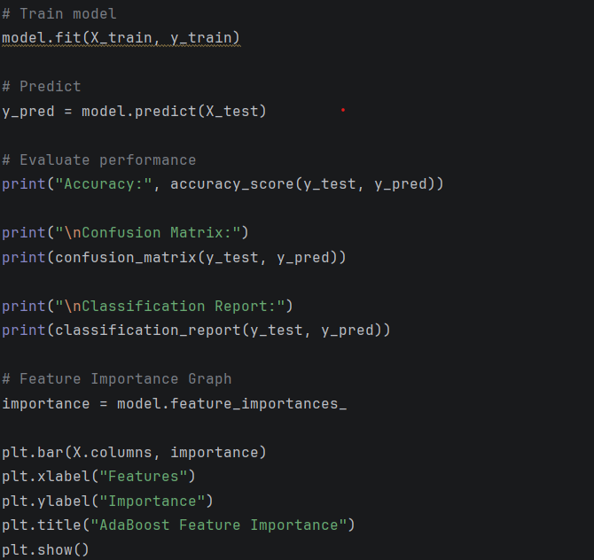

OUTPUT:
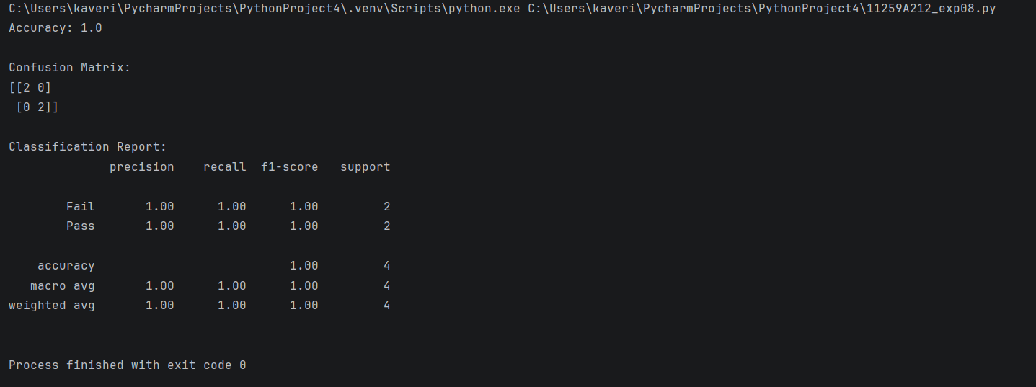

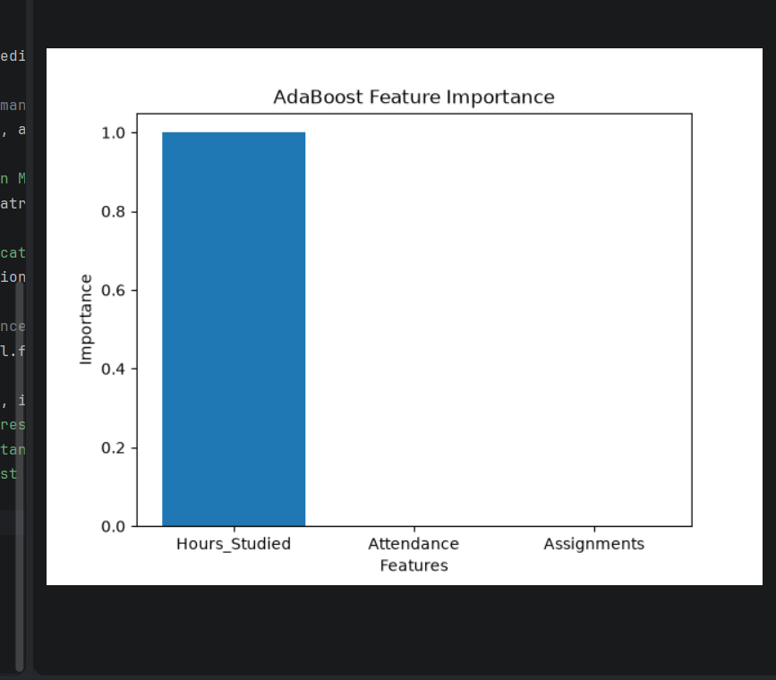

RESULTS:
Thus the AdaBoost classifier was implemented and achieved an accuracy of 1.0 (100%) on the test data. The feature importance plot shows that the model relied almost entirely on Hours_Studied (imporatance 1.00).

EX NO: 9 DATE: 9/10/26
BASIC REINFORCEMENT LEARNING MODEL (Q-LEARNING)
AIM:
To implement a basic Reinforcement Learning model using the Q-Learning algorithm.
ALGORITHM:
Step 1: Start the program and import numpy.
Step 2: Define the Rewards matrix R (6 states; -1 = no path, 0 = path, 100 = path to the goal state 5).
Step 3: Initialize the Q-table Q with zeros, set the discount factor gamma = 0.8 and the number of episodes = 1000.
Step 4: For each episode, choose a random initial state.
Step 5: While the goal state (5) has not been reached, choose a random valid action from the current state and move to the next state.
Step 6: Update the Q-value: Q(state, action) = R(state, action) = gamma x max Q(next state, all actions).
Step 7: Set the next state as the current state and repeat step 5-6 until the goal is reached;then start the next episode.
Step 8: Display the trained Q-table.
Step 9: Stop.

PROGRAM:
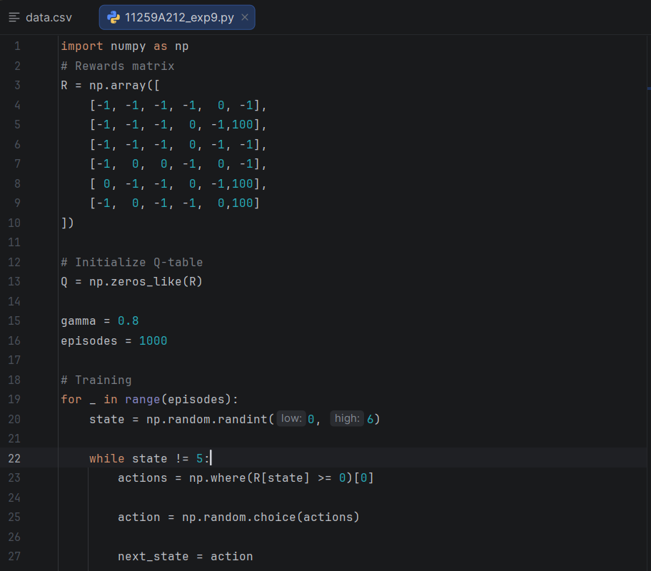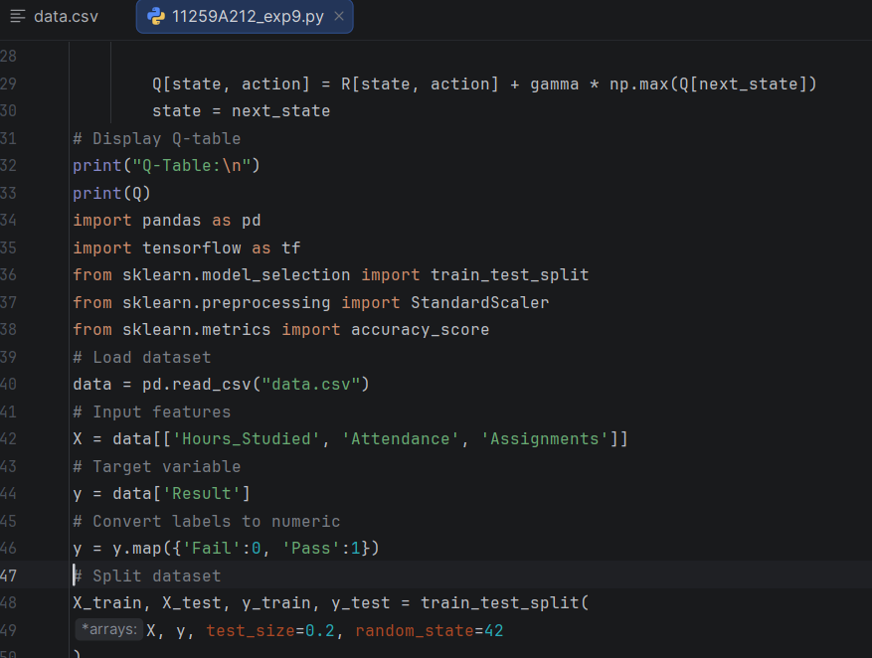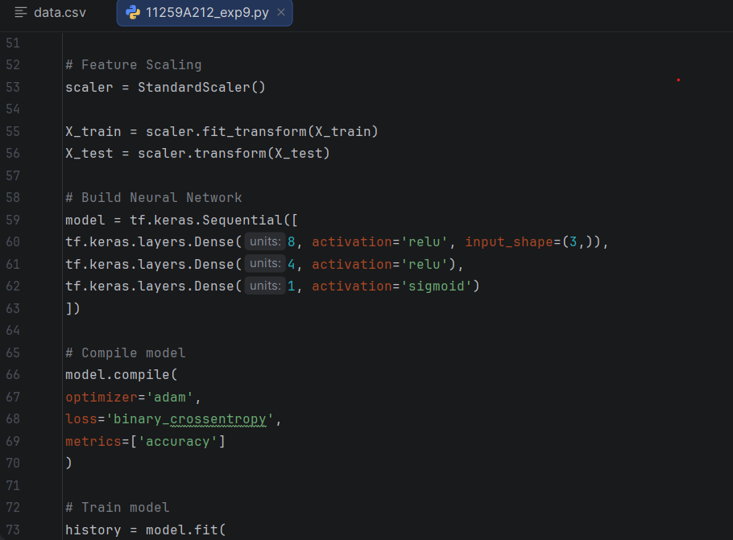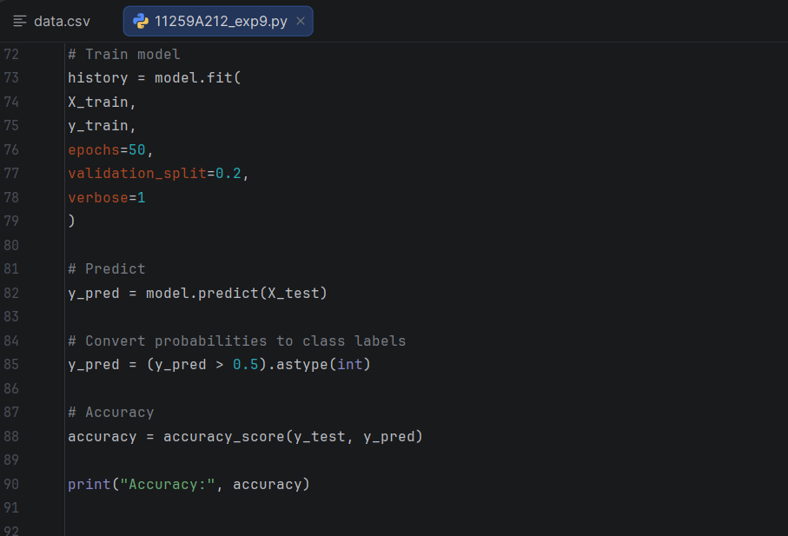

OUTPUT:
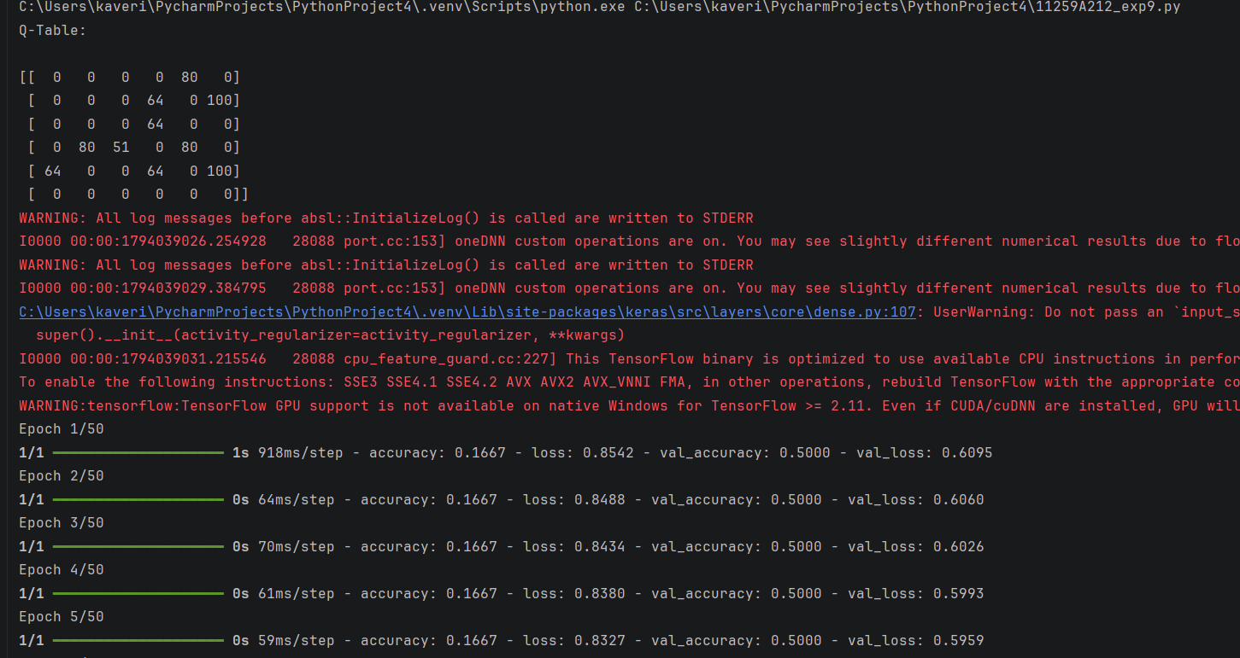

RESULT:
Thus the Q-Learning algorithm was implemented and the Q-table was obtained after 1000 episodes. Following the highest Q-value in each row gives the shortest path to the goal; for example, starting from state 2 the agent learns the path 2 → 3 → 1 → 5.

